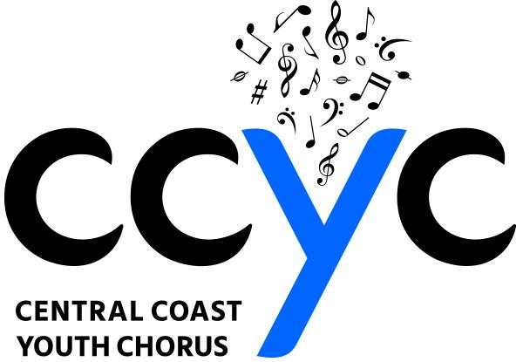
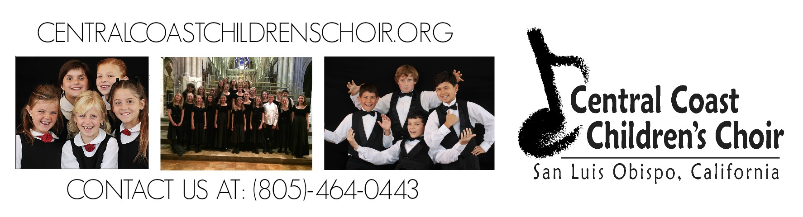
www.CentralCoastYouthChorus.org

2018-19 Sponsor Form
Your contribution underwrites choir recording fees, advertising, scholarships, guest musicians, venue overhead, and special events. You can sustain a valuable community resource for local children.
Choose the SPONSOR level below and receive the benefits:

- $150 - Artist 2 tickets to your choice of either the Holiday or Spring Concert and
special recognition in the program.

- $300 - Scholarship Fund Above benefits Plus a CD recording of selected concert and your
name or logo printed in the concert program.

- $500 - Concert Above benefits PLUS 2 extra tickets for selected concert, name or logo
included in the concert poster and business card ad in the program.

- $800 - Special Event 4 Premium seats at our Benefit Event, special recognition at event, a ⅓
size page ad in the Spring Concert program, sign placard in the lobby
of the event, printed name or logo in the Spring Concert programs and
on flyers.

- $1500 - Season 4 Premium seats at all concerts/events, a ½ page ad in each program,
special recognition at each concert/event, CD recordings of each concert, sign placard in lobby of each event, name or logo printed in concert programs and on flyers.

Name:_______________________________________ Phone:________________ Email:_____________________

Business Name:_______________________________ Sponsorship Type (from above):___________________________

Payment: Check # _____ MC/Visa/Amex: ______________________ Address:____________________________________

3-digit code: ________ Exp. _________ City, State, Zip: ________________________________

Signature:____________________________________________

